Generation Livestream: Communication and Media Production and the Virtual Afghan Sphere

Muheb Esmat

7/17/2020

In Irvine, California, Wana Miskinyar presents *Wana's Show* from the colorful green-screen studio of Ariana Afghanistan International Television. Founded in 1989, the privately-owned television channel has been a source of news and entertainment for the Afghan diaspora in the United States and Europe for decades. It is one of many television channels that served as a tool for cultural education and community building in the Afghan diaspora before the prominence of social media. Wana's guest today is Mariam, famously known as Raees Mariam (which literally translates to *boss*) by her followers on Facebook and Instagram. In a twist of fate, the star of the old screen meets the star of the new. Wana sits in an imagined green-screen studio, which adheres to the media formalities of production and presentation that give her credibility and status. On the other hand, Mariam presents her livestreams from the comfort of her own home, with no formalities beyond the mundane setting of everyday life. And yet, with the help of social media, she has effectively played a major role in the formulation of a new cultural moment in recent Afghan history. A moment in which livestreams have not only become a space for connection across physical and cultural barriers, but also the source for creating the ultimate form of reality television in the age of the internet.

The interview is unsettlingly condescending, as a mix of generational and social differences, and the patriarchal culture prevalent across Afghan communities both in and out of the country underlies most of the questions. Wana starts by asking Mariam about her living arrangements—if she lives alone, if she has any children, what her marital status is— before getting to discussing her presence and contribution to a growing cultural space built through livestreams. Beginning very soon after Facebook introduced Live in 2016, many Afghans in and out of the country have used the platform to transcend boundaries in real-time and form what I believe has become a dominant part of the Afghan virtual cultural sphere. Responding to Wana’s question about how she became famous on Facebook, Mariam humbly professes “not knowing how and is unable to point out to a singular reason.” She claims that it is her realness and persistence in not compromising her beliefs in the face of societal pressure towards women that draws people. Whatever the cause might be, what is true is that Mariam and her peers have ushered in a new era of communication and media production that has slowly taken over the spotlight from traditional media like the one that Wana built her career through.

Facebook as the Internet:

Before going further into Mariam’s case, it would be beneficial to consider the recent history of the internet in Afghanistan. In parallel with the continuously changing social and political state of the nation for more than four decades now, the introduction and development of the internet takes a singular path, even in comparison to neighboring nations. In July 2001, the Taliban government banned the internet upon the grounds of it being used as a tool for broadcasting “obscene and immoral material, and material on the internet that is against Islam.”[1] Although that ban was an extreme measure on the surface, an important fact to remember is that even before the decree there was very little public access to the internet. As a consequence of a war that had lasted more than two decades at the time, the telecommunication infrastructures were in an extremely debilitated state. Besides some foreign agencies and select wealthy Afghans that might have had access, it is reported that at the time it was “practically impossible to connect to the internet using Afghanistan's country code.”[2]

The initial steps towards public access to the internet in the country date back to 2003. As international sanctions were lifted in 2001 and borders opened to imports, the local culture fast become a den of consumerism, including that of new communication technologies. The liminal difference between public access to the internet in Afghanistan in comparison to other countries also means that the history, adoption, and role of the internet takes a varied path from the historical trajectory familiar in peaceful and technologically advanced countries. With the gradual public access to electricity, smartphones that are more economical and functional than computers that require high rates of literacy, and mobile data that includes social media packages, the Afghan community inside the country slowly found a new space to connect and build on the internet, with social media at the epicenter of it all.

The history of the internet in Afghanistan and the larger Afghan online sphere not bound to the geography of the nation-state is heavily rooted in social media. An expansive list of experiences that exist across a multiplicity of domains abroad have been consolidated to a handful of social media and video-sharing platforms. The popularity of Facebook, Instagram, Twitter, and more recently TikTok and YouTube among Afghans has grown immensely in recent years. It is to the point that even the most radical opponents of the internet, the Taliban and the religious clergy, have come to widely use social media platforms as effective grounds for promoting their ideologies. While each one of these platforms has its distinct place and importance, Facebook has been a revelation in its reframing and expansion of community networks across conflicting lines. While it is hard to pinpoint a singular reason for its popularity, I believe some of the biggest draws of Facebook have been its ability to allow users to upload any kind of media on the platform, and its diverse uses beyond social networking.

For more than four decades now, millions of Afghans have fled the country because of war and sought refuge across the world, ranging from neighboring countries of Pakistan and Iran to Europe, the United States, and Australia. For the Afghan living abroad, the platform “brings together aspects of an extended self usually separated in space and time,”[3] such as images, news, and family connection. Through this virtual sphere, a new Afghan nation has risen, one in which citizenship is available to all that have a social media account, no matter how geographically and culturally far away they might be situated.

I speculate that Facebook’s popularity as a primary space for virtual interaction also stems from its availability in local languages, the platform’s ability to allow new users to comfortably be acquainted with the unfamiliar world of the internet in the company of their friends, and more importantly, the fact that it is free to use Facebook, while you have to pay for domains on the World Wide Web. From government institutions to local news media, foreign NGOs and embassies, politicians, writers, activists, opposition leaders, to ordinary citizens, all have come to occupy the same space. A fate that is almost impossible to envision in real life, considering the recent history of conflicts in the country. Facebook has simultaneously become an important archive of the nation’s recent past and the continuing present. Considering that “Facebook both amplifies and complicates the possibilities of exchange and display, cultural production, and self-shaping,”[4] it is important to emphasize that these analyses are by no means a glorification of a corporation that is widely known for its abuse of power and lack of transparency. My analysis only covers a small part of a much larger phenomenon in an attempt at understanding its role in contemporary Afghanistan, without delving into the debate surrounding Facebook’s problems as a corporation built on commodifying our virtual presence and data.

This vast virtual sphere is in no way exempt from the rules and expectations of every day Afghan life, as it is heavily marked by the hierarchies of gender, religion, language, ethnicity, and class prevalent across Afghan society. Facebook serves as a site for the purposeful activity of social networking, but exists under a great deal of moral scrutiny. The country predominantly remains “a world divided into public and private realms, with the public world belonging almost entirely to men and with women still living mostly within compound walls sequestered from the eyes of strangers.”[5] Therefore, there is the desire to mask one’s identity online for many reasons, in particular for women living inside the country, as their public presence is subject to an array of cultural, religious, and political boundaries. On the other hand, these multiplicities of characters adopted in the public and private realm become less prevalent for Afghans like Mariam that live abroad, where their presence online can then both attract and irritate others according to their beliefs and desires.

Connection across Boundaries:

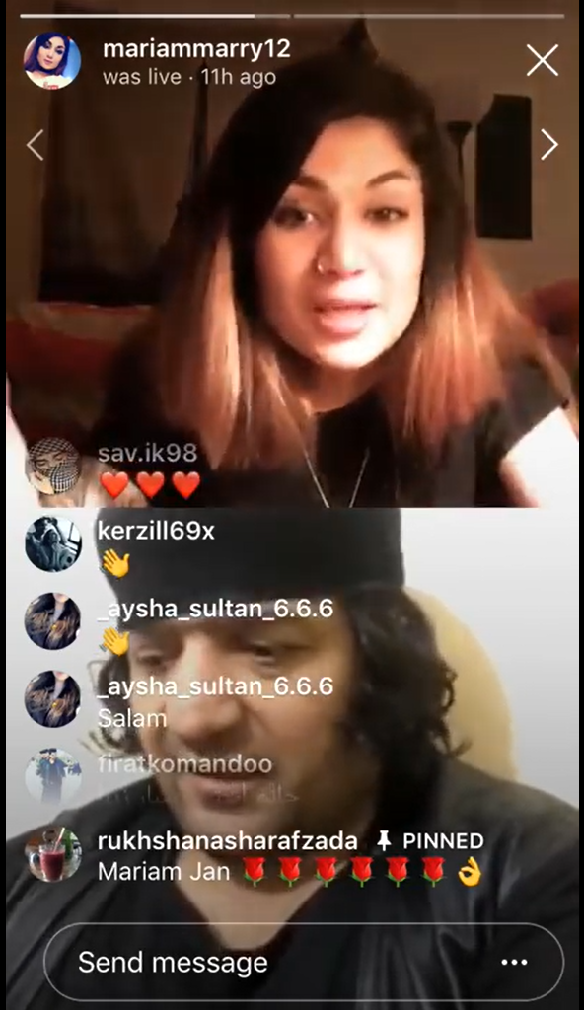

Fig. 1. Screenshot of conversation between Raees Mariam and General Mia, uploaded to YouTube by funny video.

Mariam grew up in Kabul before seeking refuge in the United States, where she began going live on Facebook. The relative distance between these two societies allows her the security to live a life that stretches beyond the boundaries set for the public presence of women in Afghan culture. Simultaneously, this alienating distance serves as a motivation to live online. As she says early on in the interview, her sole motivation to go live began with her desire to get to know people more and build connections with Afghans across the world. In his seminal essay on exile, Edward Said discusses how exile creates a sense of alienation and “while it is true that literature and history contain heroic, romantic, glorious, even triumphant episodes in an exile’s life, these are no more than efforts meant to overcome the crippling sorrow of estrangement.”[6] In Mariam’s case, the virtual sphere allows her to mediate this estrangement that comes with being physically distanced from the culture and place she used to call home and find an alternative space through which to connect to it. Through the years Mariam has come to use her platform to advocate for her rights as a woman and everyone’s right to choose the life they want to live and fight against the strict religious and traditional structures that do not allow for those choices in Afghan culture. This courageous act that has made her the direct target of both men and women, who bombard her with sexist and misogynist comments, from calling her vulgar insults such as “whore” and “infidel,” to death threats.

Stepping beyond Mariam’s beliefs, desires, and willingness to blur the lines between what is seen as private and public in Afghan culture, which has effectively earned her celebrity status through social media, it is in the mobilization of livestream that a crucial moment in contemporary Afghan history lies. Besides Mariam, there are many others, mostly living abroad, that have utilized livestreams as a space to connect and gather in the face of physical and traditional borders that make such spaces impossible to exist otherwise. Common to many attempts at the documentation of cultural history in Afghanistan, this generation’s actions are often criticized and looked down upon without any proper critique and consideration of their ingenuity in their utilization of the internet. The ingrained classism in the production and documentation of cultural histories and the misguided worship of a singular Western modernity have added to lines drawn across moral and political biases; this has often led to the exclusion of cultures produced outside the prevalent norms as worthy of attention and credit. Despite their efforts not being recognized as progression in new forms of communication and cultural production, through Facebook and Instagram Live, Mariam and her peers have continuously influenced and shaped both virtual and physical Afghan culture and ought to be taken seriously.

A typical livestream by Mariam is often conducted through Facebook and Instagram from the comfort of her home, a private space that then becomes public with a touch of the screen. She has amassed a large following of fans and critics that turn up to not only watch, but also engage with her through comments that she spends considerable time reading and reacting to. Besides being in an indirect conversation with hundreds of fans, she often hosts other livestreamers or invites fans to join the video call. Their conversations range from the discussion around everyday life to religion, politics, sex, etc., and this structure is true to how most livestreams are conducted. By conversing openly about what is often deemed culturally inappropriate or vulgar, they have created a shared theme and bond around breaking boundaries. What those boundaries consist of and how they are defined are different for each one of these Live personalities that have come to fame since Mariam.

At a basic level, livestreams facilitated by Facebook/Instagram and the internet present a communication tool that allows Afghans from Kabul to New York, Toronto, Hamburg, Sydney, and other widespread geographies to come together and create a virtual community. As a medium, these livestreams make visible the negotiations of intimacy and exchange that are shadowed by abandonment, withdrawal, and insecurity both inside Afghanistan and among its growing diaspora. This serves as an integral tool in linking together a fragmented community born out of a war that has now lasted for more than four decades. To the Afghans residing abroad, the virtual community provides what their local foreign environment lacks, where a big part of one’s identity is relegated to small communities of Afghan family and friends. Simultaneously, to the Afghans inside the country, the virtual sphere provides them with an Afghan society that often cannot be found inside the country, due to the strict cultural and religious codes that heavily emphasize a divide between private and public. Naturally, some see these rebellions and blurring of traditional boundaries and norms as a stain on their proud patriarchal culture, while others celebrate it as a form of resistance.

Social media and the internet in general have been a revelation in the framing and expansion of community networks and the Afghan virtual state that extends beyond geographical and cultural boundaries. Despite the existence of this virtual space before the introduction of Facebook and Instagram Live, this new addition that can transport one's physical image across the world in real time has been immensely popular in the Afghan community. Its ability to not limit the user’s voice to typed words, emojis, and digital reactions both makes one’s appearance more real and also narrows down the number of people who will then occupy that space. While it may seem easy to an outsider, it takes much more courage to publicly face people on livestream than in a chat room. In a way, the addition of livestreams has created a space within the larger social media space. While globally, livestreams have become ever more present during the recent pandemic that has forced everyone into self-exile, for societies like Afghanistan this estrangement and exile have been common for decades. Hence the appetite for and prevalence of livestreams in Afghanistan before the pandemic are no longer so difficult to grasp.

Reality Television:

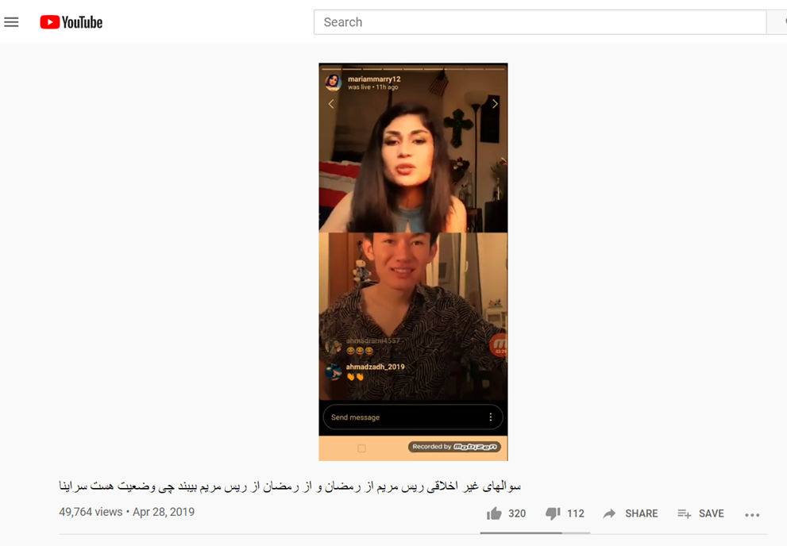

Fig. 2. Screenshot of Mariam's livestream on YouTube channel Funny 420.

Beyond facilitating connections across borders and boundaries, livestreams have ushered in a new era of media production, which I believe to be the ultimate form of reality television. Traditionally, television has been a dominant player in the production and dispersal of media in Afghanistan since its rebirth after the fall of the Taliban. Mariam and her peer’s livestreams enter a second life once that “end” button is pushed on the screen. Recorded by fans and some of the online personalities themselves, these conversations are then reuploaded to a growing number of Facebook, Instagram, and YouTube pages. It is in this transition from social media account to YouTube that these livestreams are then spread far and wide, garnering from thousands to even millions of views and in the process becoming part of a new wave of media production that is taking place on YouTube.

For years now, Mariam’s livestreams have been relentlessly intimate and vulnerably real about her life in the past and present. From her happiest moments in the company of friends to her contemplation of suicide, abortion, break up, love, and everything else in between, all takes place in front of a camera. Since Mariam’s early days as one of the pioneers of this new phenomenon, the cult of personalities joining the movement has grown to include Hania Mazari (famously known as Shoy Shar), General Mya, Mahfouz, Qomandan Robika, Najeeb, Natasha, Najeeb-e-Borot, and many more. In YouTube, they have not only found an informal archive, but also an informal channel to produce an updated form of reality television. Taking the medium of livestreams as the overarching show, these characters constitute the cast of a reality show built around the drama of their connections and clash of their personalities online.

In recent decades, reality TV has occupied an important place globally in contemporary television culture. In their book, *Understanding Reality Television*, Su Holmes and Deborah Jermyn write that some “early attempts to define reality TV emphasized the importance of a focus on ‘real-life’ and ‘real people’ as the crucial criteria, as well as the technological forms through which the subject matter was mediated (such as the video camcorder).”[7] The genre has expanded drastically in recent decades and includes a wide range of examples that go from talk shows to talent and game shows, courtrooms, reality soap operas, and confined dramatization of a search for love. Because of the category’s fluid and expandable boundaries, it is both able to absorb new forms and also avoid being bound to a particular definition. An important factor in the genre's appeal and success is the ideology of the “real” that serves as an anchor to all forms that have evolved from it. In the past two decades, Afghan television viewers have been witness to several reality-based shows that include: *Afghan Star* (a talent show based on *American Idol*), a local adaptation of *The Voice*, *Who Wants to Be a Millionaire*, *Khanda Bazar* (similar to *Afghan Star* but solely for comedians), and cop shows that mix real footage with reenacted scenes and many more.

Coming back to the interview on *Wana’s Show*, Wana asks Mariam whether her online self is her real character or if she acts this way for publicity, to which Mariam responds “how she appears on livestreams is my real personality.” She further explains that she sees no need to play a role and to appear in a different character in the eyes of the people watching her online. The claim of Mariam and her peers to the “real” is also supported by the fact that they were regular citizens and not actors before their eventual social media stardom. The rhetoric of “real” is further solidified with the “Live” stamp at the top left corner and the visual structure of split screens that we have come to associate with livestreams in general. In their eventual existence on YouTube, mostly consisting of mere screen grabs, the viewer is still presented with these signifiers of the livestream, even if it is no longer live, but a recording. Livestreams here constitute the simulated structure that hosts reality TV, in the same way that fabricated environments have come to define the setting of most reality TV programing.

Simultaneously, these recordings also expand the spectacle to include not only Mariam and her guests, but also the comments, reactions, and the viewer counts as they took place when they were live. This effectively expands the show to a much wider spectacle that centers around more than just the two main participants that share the screens. Without a script, the participants and the audience produce moments of total exposition with semi-foreigners and actual foreigners. Just like traditional reality TV programming that heavily relies on the show's ability to generate gossip and comments as an indicator of its success, because of their ability to simultaneously be attractive and repulsive, the success of these livestreams is driven by their shock value in the face of strict social and cultural orders. From the many hours of actual livestreams, the most shocking moments (considering that this shocking moment could vary according to the taste of the person that then acts as the producer) are cherry-picked and uploaded to YouTube by a growing list of accounts that are rapidly sharing new and recycled media for virtual consumption.

Beyond these similarities to traditional forms of reality TV, Mariam and her peers have prevailed over the need for official networks, producers, and lavish sets to effectively reinvent the genre. The general public’s fascination with the “real,” which has been a global phenomenon in recent media history, has been transferred from the traditional medium of structurally produced television to a more democratic medium in social media. Of course, this claim to democracy is in comparison to television and cinema, which are highly hierarchical, and it does not refute the inherent restrictions and shortcomings that come with the internet and social media itself. Despite the grand claim of reality TV to realness interwoven with the rhetoric of liveness, traditional television viewers in actuality do not see the live coverage. These shows and moments of liveness that we experience as viewers are the product of seamless editing that maneuvers viewers into accepting that what is in front of them is happening in real time, famously used by shows based on contests and prizes. In this new formation of livestreams, the audience not only gets to see these real personalities intimately close on their screens, but also has the opportunity to directly engage with them if they wish to, which is often the case with fans that join the livestreams through the comment sections or direct video chat. This interactive experience allows the audience to effectively become part of the show and personally verify its “realness.”

The same audience that enjoys an intimate acquaintance with Mariam also knowingly and unknowingly become producers and directors of the eventual reality TV media on YouTube. With no regard for Mariam and her participant’s rights, some of the viewers record parts of her livestream and upload it to YouTube. Their selections are clearly driven by the basic formula of what will create a buzz and earn them views, an informal currency in the world of spectacle media viewership. These viewers turned producers are the “the omnipresent yet invisible cameramen”[8] that also foreground their moral imperatives about Mariam and other personalities characters through their selection. In essence, this whole process, which starts with Mariam going Live and ends on YouTube channels with hundreds of thousands of views, travels through a list of complex social and political forces that leave their distinct mark in each step. The reality shows that have been taking shape surrounding livestreams in Afghan society teach us lessons about virtual connections and also reflect a new era of Afghan media production. Mariam and her peers have ushered in a new era of community building across social and physical borders through the virtual sphere. Such communities do not replace the necessity of the real sphere of in-person communication, but rather indicate the expansion, through livestreams, of the fields of communication and community building in the face of exile and physical and cultural boundaries.

I write this essay in consideration of our growing reliance upon livestreams as a means for mediating our self-exile in the world outside of Afghanistan. Today, the proliferation of livestreaming could be seen as a by-product of the global pandemic, but in reality, dating such practices differs across geographies and cultures. As histories of the current moment will come to be written, we should consider the fact that certain geographies, in this case Afghanistan, as a consequence of their sociopolitical state, have had to bear the consequences of exile before the pandemic. While it has now become common in the Western context to use livestreams as a means for education, community building, and entertainment, Mariam and her peers have utilized the medium as an effective form of communication for years.

Through the medium of livestreams, Mariam and her peers have knowingly or unknowingly contributed to the creation of a new online space for dialogue, conversation, and community that in-person could only exist underground or otherwise risk extreme consequences in Afghan communities in and out of the country. The online personalities of this new generation have become cultural icons (in some sense they could be termed their own counterculture), whose images and videos are reused, parodied, and ironically consumed, which in no way diminishes the fact that they are cultural producers with real impact. Mariam’s use of livestream and her role in contemporary Afghan society need further evaluation beyond the axiological approach that is often cast upon her and other Live personalities. Beyond facilitating a particular belonging, these livestreams have ushered in a new era of visual culture that is slowly bringing the internet and social media on par, if not above, traditional television as sources of entertainment and media production among Afghans.

Whether this moment will come to be accepted as a true development in a new form of reality TV production is contingent on many factors, including further in-depth study of the phenomenon and also a general move towards documenting and understanding Afghan culture beyond the singular definition that it often is forced into. What is undeniably true is that this a real moment of ingenuity formed through the collision of technology and culture; culture, which said technology often neglects to take into consideration because of its Silicon Valley origins invested in Western contemporaneity. Reality TV or not, Mariam and her peers have ushered in a new era of media production that has and continues to leave a mark in contemporary Afghan culture and is growing to be a major source of entertainment and cultural production.

Bibliography

Ansary, Tamim. *Games without Rules: The Often-Interrupted History of Afghanistan.* New York: Public Affairs, 2014.

Holmes, Su, and Deborah Jermyn. *Understanding Reality Television*. London: Routledge, 2004.

Kavka, Misha. “Love ’n the Real; or, How I Learned to Love Reality TV.” In *The Spectacle of the Real: From Hollywood to “Reality” TV and Beyond*, edited by Geoff King, 93–104. Bristol, UK / Portland, Or: Intellect, 2005.

McKay, Deirdre. “On Facebook.” *An Archipelago of Care: Filipino Migrants and Global Networks,* 51–69. Bloomington, IN: Indiana University Press, 2016.

DOI: 10.2307/j.ctt2005rbn.9.

Said, Edward W. *Reflections on Exile and Other Essays*. London: Granta Books, 2012.

*BBC News,* “Taleban ‘Outlaw Internet,’” July 13, 2001. news.bbc.co.uk/2/hi/south_asia/1437852.stm.

1. *BBC News*, “Taleban ‘Outlaw Internet,’” 13 July 2001.
2. Ibid.
3. Deirdre McKay, “On Facebook,” in *An Archipelago of Care: Filipino Migrants and Global Networks*, (Indiana University Press, 2016), 51.
4. Idem.
5. Tamim Ansary, *Games without Rules: The Often-Interrupted History of Afghanistan* (New York: PublicAffairs, 2014), 393.
6. Edward W. Said, *Reflections on Exile: and Other Essays* (London: Granta, 2012), 137.
7. Su Holmes and Deborah Jermyn, *Understanding Reality Television* (London: Routledge 2004), 5.
8. Misha Kavka. “Love ’n the Real; or, How I Learned to Love Reality TV,” in *The Spectacle of the Real: From Hollywood to “Reality” TV and Beyond*, ed. Geoff King (Bristol, UK / Portland, Or: Intellect, 2005), 98.